

**Project Report**

Statistics For Data Science -- II

Student Depression Dataset

By

Shivam Patel

Reg No.2411021240016

Department of Computer Application Alliance University

Chandpur — Anekal Main Road, Anekal Bengaluru — 562 106

April 2025

Introduction

In recent years, mental health challenges among students have garnered significant attention. With academic, social, and personal pressures on the rise, it has become increasingly important to identify factors contributing to depression in student populations. This study aims to analyse a dataset comprising various attributes of students—such as age, gender, academic pressure, CGPA, dietary habits, sleep duration, and more—to explore potential correlations with depression levels. The main objective is to leverage data analytics to uncover patterns that could inform preventive strategies and support systems for student well-being.

Methodology

The analysis utilized a dataset of **27,901 student records**, each containing 18 features including demographic, academic, lifestyle, and psychological factors. The dataset was processed using **Python** with libraries such as **Pandas**, **Seaborn**, and **Matplotlib** for data manipulation and visualization.

**Steps in the methodology included:**

**Data Exploration & Cleaning:** Loading the dataset and examining structure, types, and basic statistics.

**Univariate Analysis:** Distribution plots and pie charts were used to visualize individual variables like age, CGPA, gender distribution, dietary habits, and sleep duration.

**Bivariate Analysis:** Relationships between depression and variables like gender, CGPA, academic pressure, and work/study hours were analysed using scatter plots and box plots.

**Multivariate Analysis:** Pair plots and multivariate scatter plots were generated to analyse how multiple factors interact in relation to depression.

**Correlation Analysis:** A heatmap of correlation coefficients was produced to identify the strongest linear relationships between numerical variables

Conclusion

The analysis revealed several insights into student depression patterns. Academic pressure and poor CGPA were frequently associated with higher levels of depression. Gender differences were observed, with a notable percentage of female students reporting symptoms of depression. Sleep duration and dietary habits also showed moderate associations with mental health status.

These findings underscore the multifactorial nature of depression in students and emphasize the need for holistic support systems that address academic, psychological, and lifestyle aspects. Future work could enhance this analysis by incorporating longitudinal data and machine learning models to predict at-risk individuals more accurately.

## GitHub Link: https://github.com/shivam88309/statistics-for-data-science

In [1]:

*#data set of student depression Dataset*

**import** pandas **as** pd

**import** seaborn **as** sns

**import** matplotlib.pyplot **as** plt

shivam**=**pd**.**read_csv(r"E:\student depression\student_depression_dataset.csv") shivam

Out[1]:

|  |  |  |  |  |  |  |  |  |
| --- | --- | --- | --- | --- | --- | --- | --- | --- |
| **id** | **Gender** | **Age** | **City** | **Profession** | **Academic Pressure** | **Work Pressure** | **CGPA** | **S** |

|  |  |  |  |  |  |  |  |  |
| --- | --- | --- | --- | --- | --- | --- | --- | --- |
| **0** | 2 | Male | 33.0 | Visakhapatnam | Student | 5.0 | 0.0 | 8.97 |
| **1** | 8 | Female | 24.0 | Bangalore | Student | 2.0 | 0.0 | 5.90 |
| **2** | 26 | Male | 31.0 | Srinagar | Student | 3.0 | 0.0 | 7.03 |
| **3** | 30 | Female | 28.0 | Varanasi | Student | 3.0 | 0.0 | 5.59 |
| **4** | 32 | Female | 25.0 | Jaipur | Student | 4.0 | 0.0 | 8.13 |
| **...** | ... | ... | ... | ... | ... | ... | ... | ... |
| **27896** | 140685 | Female | 27.0 | Surat | Student | 5.0 | 0.0 | 5.75 |
| **27897** | 140686 | Male | 27.0 | Ludhiana | Student | 2.0 | 0.0 | 9.40 |
| **27898** | 140689 | Male | 31.0 | Faridabad | Student | 3.0 | 0.0 | 6.61 |
| **27899** | 140690 | Female | 18.0 | Ludhiana | Student | 5.0 | 0.0 | 6.88 |
| **27900** | 140699 | Male | 27.0 | Patna | Student | 4.0 | 0.0 | 9.24 |

27901 rows × 18 columns

shivam**.**head (20)

 

In [3]:

Out[3]:

|  |  |  |  |  |  |  |  |  |
| --- | --- | --- | --- | --- | --- | --- | --- | --- |
| **id** | **Gender** | **Age** | **City** | **Profession** | **Academic Pressure** | **Work Pressure** | **CGPA** | **St Satisfact** |

|  |  |  |  |  |  |  |  |  |
| --- | --- | --- | --- | --- | --- | --- | --- | --- |
| **0** | 2 | Male | 33.0 | Visakhapatnam | Student | 5.0 | 0.0 | 8.97 |
| **1** | 8 | Female | 24.0 | Bangalore | Student | 2.0 | 0.0 | 5.90 |
| **2** | 26 | Male | 31.0 | Srinagar | Student | 3.0 | 0.0 | 7.03 |
| **3** | 30 | Female | 28.0 | Varanasi | Student | 3.0 | 0.0 | 5.59 |
| **4** | 32 | Female | 25.0 | Jaipur | Student | 4.0 | 0.0 | 8.13 |
| **5** | 33 | Male | 29.0 | Pune | Student | 2.0 | 0.0 | 5.70 |
| **6** | 52 | Male | 30.0 | Thane | Student | 3.0 | 0.0 | 9.54 |
| **7** | 56 | Female | 30.0 | Chennai | Student | 2.0 | 0.0 | 8.04 |
| **8** | 59 | Male | 28.0 | Nagpur | Student | 3.0 | 0.0 | 9.79 |

|  |  |  |  |  |  |  |  |  |
| --- | --- | --- | --- | --- | --- | --- | --- | --- |
| **9** | 62 | Male | 31.0 | Nashik | Student | 2.0 | 0.0 | 8.38 |
| **10** | 83 | Male | 24.0 | Nagpur | Student | 3.0 | 0.0 | 6.10 |
| **11** | 91 | Male | 33.0 | Vadodara | Student | 3.0 | 0.0 | 7.03 |

|  |  |  |  |  |  |  |  |
| --- | --- | --- | --- | --- | --- | --- | --- |
| **12** 94 | Male | 27.0 | Kalyan | Student | 5.0 | 0.0 | 7.04 |
| **13** 100 | Female | 19.0 | Rajkot | Student | 2.0 | 0.0 | 8.52 |
| **14** 103 | Female | 19.0 | Kalyan | Student | 5.0 | 0.0 | 5.64 |
| **15** 106 | Male | 29.0 | Srinagar | Student | 3.0 | 0.0 | 8.58 |

**id Gender Age City Profession Academic Pressure**

**Work Pressure**

**CGPA St**

**Satisfact**

|  |  |  |  |  |  |  |  |
| --- | --- | --- | --- | --- | --- | --- | --- |
| **16** 120 | Male | 25.0 | Nashik | Student | 5.0 | 0.0 | 6.51 |
| **17** 132 | Female | 20.0 | Ahmedabad | Student | 5.0 | 0.0 | 7.25 |
| **18** 139 | Male | 19.0 | Chennai | Student | 2.0 | 0.0 | 7.83 |
| **19** 145 | Male | 25.0 | Kalyan | Student | 3.0 | 0.0 | 9.93 |

In [5]:

shivam**.**tail (20)

Out[5]:

|  |  |  |  |  |  |  |  |  |
| --- | --- | --- | --- | --- | --- | --- | --- | --- |
| **id** | **Gender** | **Age** | **City** | **Profession** | **Academic Pressure** | **Work Pressure** | **CGPA** | **Satis** |

|  |  |  |  |  |  |  |  |  |
| --- | --- | --- | --- | --- | --- | --- | --- | --- |
| **27881** | 140564 | Male | 27.0 | Surat | Student | 4.0 | 0.0 | 5.16 |
| **27882** | 140568 | Female | 28.0 | Vasai-Virar | Student | 2.0 | 0.0 | 5.86 |
| **27883** | 140584 | Female | 22.0 | Kanpur | Student | 4.0 | 0.0 | 6.61 |
| **27884** | 140594 | Male | 18.0 | Meerut | Student | 5.0 | 0.0 | 6.25 |
| **27885** | 140597 | Female | 19.0 | Mumbai | Student | 2.0 | 0.0 | 9.21 |
| **27886** | 140601 | Female | 22.0 | Jaipur | Student | 5.0 | 0.0 | 9.25 |
| **27887** | 140624 | Male | 32.0 | Rajkot | Student | 4.0 | 0.0 | 9.19 |
| **27888** | 140630 | Male | 19.0 | Kolkata | Student | 4.0 | 0.0 | 7.13 |
| **27889** | 140631 | Male | 33.0 | Ahmedabad | Student | 1.0 | 0.0 | 5.70 |
| **27890** | 140635 | Male | 28.0 | Ludhiana | Student | 3.0 | 0.0 | 5.03 |
| **27891** | 140645 | Female | 28.0 | Thane | Student | 4.0 | 0.0 | 7.77 |
| **27892** | 140669 | Female | 20.0 | Indore | Student | 3.0 | 0.0 | 7.72 |
| **27893** | 140672 | Female | 24.0 | Hyderabad | Student | 3.0 | 0.0 | 6.02 |
| **27894** | 140681 | Male | 23.0 | Srinagar | Student | 3.0 | 0.0 | 6.00 |
| **27895** | 140684 | Male | 31.0 | Lucknow | Student | 2.0 | 0.0 | 7.27 |

**id Gender Age City Profession Academic**

**Pressure**

**Work Pressure**

**CGPA**

**Satis**

|  |  |  |  |  |  |
| --- | --- | --- | --- | --- | --- |
| **id** | **Age** | **Academic Pressure** | **Work Pressure** | **CGPA** | **S**  **Satisfa** |

|  |  |  |  |  |  |  |  |  |
| --- | --- | --- | --- | --- | --- | --- | --- | --- |
| **27896** | 140685 | Female | 27.0 | Surat | Student | 5.0 | 0.0 | 5.75 |
| **27897** | 140686 | Male | 27.0 | Ludhiana | Student | 2.0 | 0.0 | 9.40 |
| **27898** | 140689 | Male | 31.0 | Faridabad | Student | 3.0 | 0.0 | 6.61 |
| **27899** | 140690 | Female | 18.0 | Ludhiana | Student | 5.0 | 0.0 | 6.88 |
| **27900** | 140699 | Male | 27.0 | Patna | Student | 4.0 | 0.0 | 9.24 |

|  |  |  |  |  |  |  |
| --- | --- | --- | --- | --- | --- | --- |
| In [7]: | shivam**.**describe() |  | | | | |
| Out[7]: |  |  |  |  |  |  |
|  | **count** 27901.000000 | 27901.000000 | 27901.000000 | 27901.000000 | 27901.000000 | 27901.00 |
|  | **mean** 70442.149421 | 25.822300 | 3.141214 | 0.000430 | 7.656104 | 2.94 |
|  | **std** 40641.175216 | 4.905687 | 1.381465 | 0.043992 | 1.470707 | 1.36 |
|  | **min** 2.000000 | 18.000000 | 0.000000 | 0.000000 | 0.000000 | 0.00 |
|  | **25%** 35039.000000 | 21.000000 | 2.000000 | 0.000000 | 6.290000 | 2.00 |
|  | **50%** 70684.000000 | 25.000000 | 3.000000 | 0.000000 | 7.770000 | 3.00 |
|  | **75%** 105818.000000 | 30.000000 | 4.000000 | 0.000000 | 8.920000 | 4.00 |
|  | **max** 140699.000000 | 59.000000 | 5.000000 | 5.000000 | 10.000000 | 5.00 |
|  |  |  |  |  |  |  |
|  |  |  |  |  |  |  |

In [9]:

shivam**.**info()

<class 'pandas.core.frame.DataFrame'> RangeIndex: 27901 entries, 0 to 27900 Data columns (total 18 columns):

# Column Non-Null Count Dtype

|  |  |  |  |  |  |
| --- | --- | --- | --- | --- | --- |
| 0 id |  | 27901 | non-null |  | int64 |
| 1 Gender |  | 27901 | non-null |  | object |
| 2 Age |  | 27901 | non-null |  | float64 |
| 3 City |  | 27901 | non-null |  | object |
| 4 Profession |  | 27901 | non-null |  | object |
| 5 Academic Pressure |  | 27901 | non-null |  | float64 |
| 6 Work Pressure |  | 27901 | non-null |  | float64 |
| 7 CGPA |  | 27901 | non-null |  | float64 |
| 8 Study Satisfaction |  | 27901 | non-null |  | float64 |
| 9 Job Satisfaction |  | 27901 | non-null |  | float64 |
| 10 Sleep Duration |  | 27901 | non-null |  | object |
| 11 Dietary Habits |  | 27901 | non-null |  | object |
| 12 Degree |  | 27901 | non-null |  | object |
| 13 Have you ever had suicidal thoughts | ? | 27901 | non-null |  | object |
| 14 Work/Study Hours |  | 27901 | non-null |  | float64 |
| 15 Financial Stress |  | 27901 | non-null |  | object |
| 16 Family History of Mental Illness |  | 27901 | non-null |  | object |
| 17 Depression |  | 27901 | non-null |  | int64 |
| dtypes: float64(7), int64(2), object(9) |  |  |  |  |  |

memory usage: 3.8+ MB

In [11]:

shivam**.**describe

Out[11]:

<bound method NDFrame.describe of id Gender Age City Pr ofession Academic Pressure \

|  |  |  |  |  |  |  |  |  |  |  |  |
| --- | --- | --- | --- | --- | --- | --- | --- | --- | --- | --- | --- |
| 0 | 2 | | Male | 33.0 | Visakhapatnam | | | Student | | | 5.0 |
| 1 | 8 | | Female | 24.0 | Bangalore | | | Student | | | 2.0 |
| 2 | 26 | | Male | 31.0 | Srinagar | | | Student | | | 3.0 |
| 3 | 30 | | Female | 28.0 | Varanasi | | | Student | | | 3.0 |
| 4 | 32 | | Female | 25.0 | Jaipur | | | Student | | | 4.0 |
| ... | ... | | ... | ... | ... | | | ... | | | ... |
| 27896 | 140685 | | Female | 27.0 | Surat | | | Student | | | 5.0 |
| 27897 | 140686 | | Male | 27.0 | Ludhiana | | | Student | | | 2.0 |
| 27898 | 140689 | | Male | 31.0 | Faridabad | | | Student | | | 3.0 |
| 27899 | 140690 | | Female | 18.0 | Ludhiana | | | Student | | | 5.0 |
| 27900 | 140699 | | Male | 27.0 | Patna | | | Student | | | 4.0 |
|  | Work | Pressure | | CGPA | Study | Satisfaction | | Job | Satisfaction | | \ |
| 0 |  | 0.0 | | 8.97 |  | 2.0 | |  | 0.0 | |  |
| 1 |  | 0.0 | | 5.90 |  | 5.0 | |  | 0.0 | |  |
| 2 |  | 0.0 | | 7.03 |  | 5.0 | |  | 0.0 | |  |
| 3 |  | 0.0 | | 5.59 |  | 2.0 | |  | 0.0 | |  |
| 4  ... 27896 |  | 0.0  ... 0.0 | | 8.13  ... 5.75 |  | 3.0  ... 5.0 | |  | 0.0  ... 0.0 | |  |
| 27897 |  | 0.0 | | 9.40 |  | 3.0 | |  | 0.0 | |  |
| 27898 |  | 0.0 | | 6.61 |  | 4.0 | |  | 0.0 | |  |
| 27899 |  | 0.0 | | 6.88 |  | 2.0 | |  | 0.0 | |  |
| 27900 |  | 0.0 | | 9.24 |  | 1.0 | |  | 0.0 | |  |
|  |  | Sleep Duration | | | Dietary Habits | | Degree | | | \ | |
| 0 |  | '5-6 hours' | | | Healthy | | B.Pharm | | |  | |
| 1 |  | '5-6 hours' | | | Moderate | | BSc | | |  | |
| 2 | 'Less | than 5 hours' | | | Healthy | | BA | | |  | |
| 3 |  | '7-8 hours' | | | Moderate | | BCA | | |  | |
| 4  ... 27896 |  | '5-6 hours'  ...  '5-6 hours' | | | Moderate  ...  Unhealthy | | M.Tech  ...  'Class 12' | | |  | |
| 27897 | 'Less | than 5 hours' | | | Healthy | | MSc | | |  | |
| 27898 |  | '5-6 hours' | | | Unhealthy | | MD | | |  | |
| 27899 | 'Less | than 5 hours' | | | Healthy | | 'Class 12' | | |  | |
| 27900 | 'Less | than 5 hours' | | | Healthy | | BCA | | |  | |

Have you ever had suicidal thoughts ? Work/Study Hours \

|  |  |  |
| --- | --- | --- |
| 0 | Yes | 3.0 |
| 1 | No | 3.0 |
| 2 | No | 9.0 |
| 3 | Yes | 4.0 |
| 4 | Yes | 1.0 |
| ... | ... | ... |
| 27896 | Yes | 7.0 |
| 27897 | No | 0.0 |
| 27898 | No | 12.0 |
| 27899 | Yes | 10.0 |
| 27900 | Yes | 2.0 |

Financial Stress Family History of Mental Illness Depression

0 1.0 No 1

1 2.0 Yes 0

2 1.0 Yes 0

3 5.0 Yes 1

4 1.0 No 0

... ... ... ...

|  |  |  |  |
| --- | --- | --- | --- |
| 27896 | 1.0 | Yes | 0 |
| 27897 | 3.0 | Yes | 0 |
| 27898 | 2.0 | No | 0 |
| 27899 | 5.0 | No | 1 |
| 27900 | 3.0 | Yes | 1 |

[27901 rows x 18 columns]>

In [149…

*# Univariate Analysis: Numerical*

sns**.**histplot(shivam['Age'], kde**=True**)**.**set_title('Age Distribution') plt**.**show()

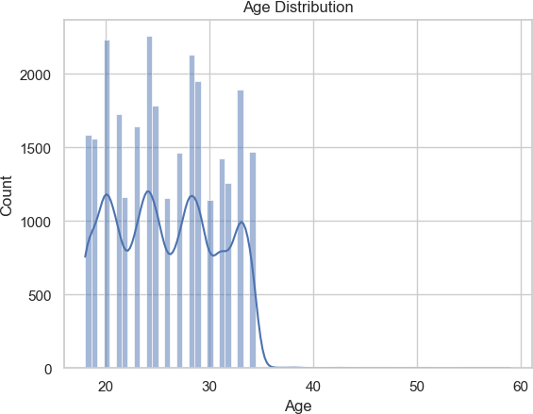

In [141…

*# Univariate Analysis: Numerical*

sns**.**histplot(shivam['CGPA'], kde**=True**)**.**set_title('CGPA Distribution') plt**.**show()

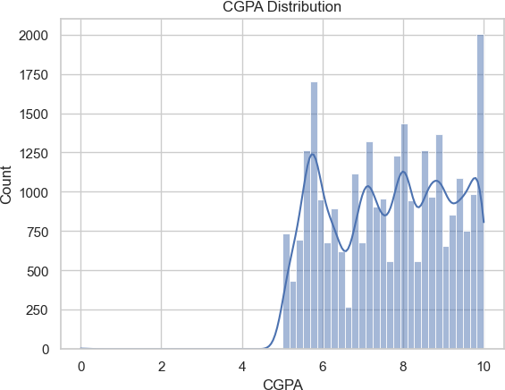

In [143…

*# Univariate Analysis: Numerical*

sns**.**histplot(shivam['Work/Study Hours'], kde**=True**)**.**set_title('Work/Study Hours D plt**.**show()

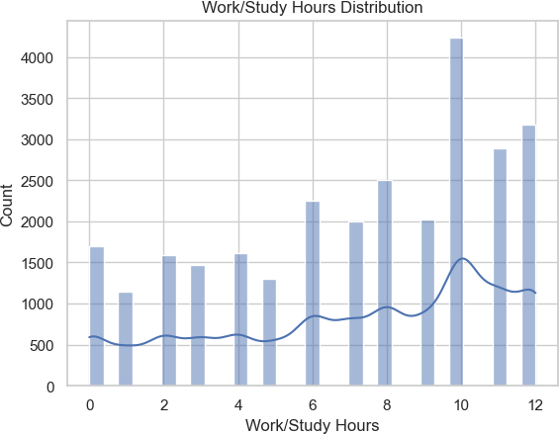

In [32]:

*# Univariate Analysis: Categorical*

sns**.**countplot(x**=**'Gender', data**=**shivam)**.**set_title('Gender Count') plt**.**show()

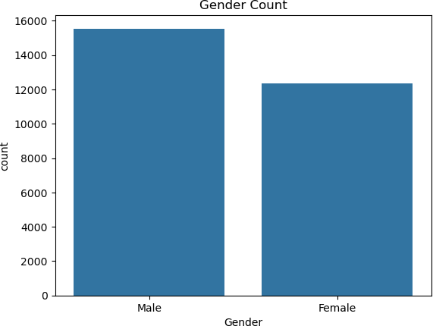

In [61]:

*# Univariate Pie Chart: Gender distribution* gender_counts **=** shivam['Gender']**.**value_counts() plt**.**figure(figsize**=**(6, 6))

plt**.**pie(gender_counts, labels**=**gender_counts**.**index, autopct**=**'%1.1f%%', startangle plt**.**title('Gender Distribution')

plt**.**show()

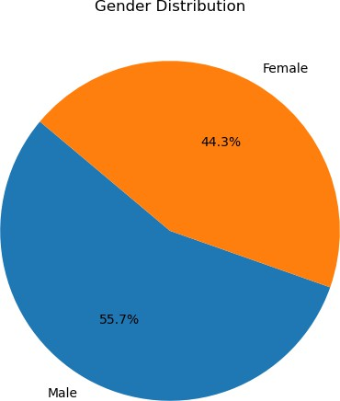

In [34]:

*# Univariate Analysis: Categorical*

sns**.**countplot(x**=**'Depression', data**=**shivam)**.**set_title('Depression Count') plt**.**show()

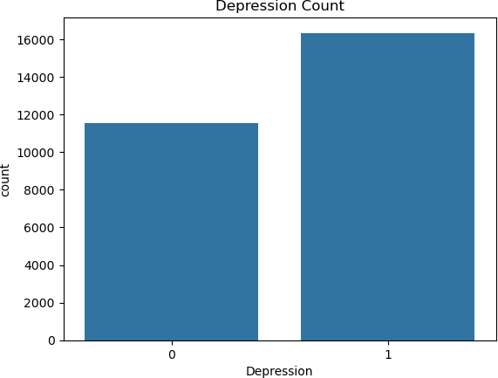

In [63]:

*# Univariate Pie Chart: Depression distribution* depression_counts **=** shivam['Depression']**.**value_counts() plt**.**figure(figsize**=**(6, 6))

plt**.**pie(depression_counts, labels**=**['Not Depressed', 'Depressed'], autopct**=**'%1.1f plt**.**title('Depression Distribution')

plt**.**show()

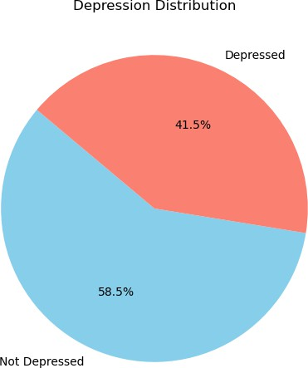

In [36]:

*# Univariate Analysis: Categorical*

sns**.**countplot(x**=**'Dietary Habits', data**=**shivam)**.**set_title('Dietary Habits') plt**.**show()

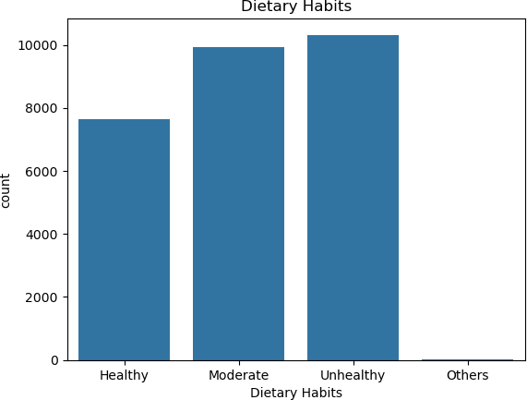

In [65]:

*# Univariate Pie Chart: Dietary Habits*

diet_counts **=** shivam['Dietary Habits']**.**value_counts() plt**.**figure(figsize**=**(6, 6))

plt**.**pie(diet_counts, labels**=**diet_counts**.**index, autopct**=**'%1.1f%%', startangle**=**140 plt**.**title('Dietary Habits Distribution')

plt**.**show()

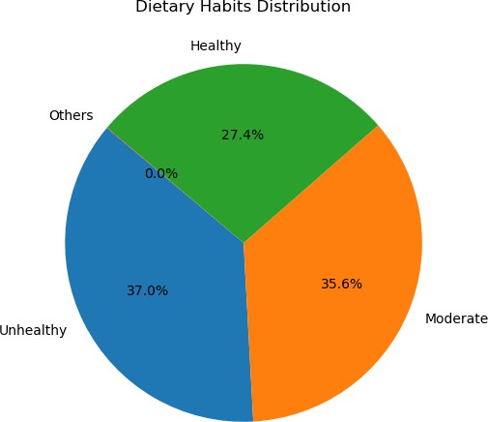

In [109…

*#Age vs Academic Pressure Colored by Dietary Habits scaatter plot* sns**.**scatterplot(x**=**'Age', y**=**'Academic Pressure',hue**=**'Dietary Habits', data**=**adars plt**.**title('Age vs Academic Pressure Colored by Dietary Habits') plt**.**xlabel('Age')

plt**.**ylabel('Academic Pressure') plt**.**grid(**True**)

plt**.**show()

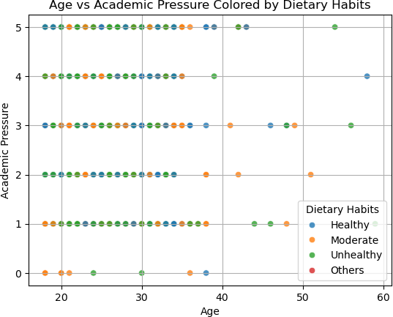

In [93]:

*# Scatter plot colored by Gender*

sns**.**scatterplot(x**=**'CGPA', y**=**'Work/Study Hours', hue**=**'Gender', data**=**aa, alpha**=**0.7 plt**.**title('CGPA vs Work/Study Hours Colored by Gender')

plt**.**xlabel('CGPA') plt**.**ylabel('Work/Study Hours') plt**.**grid(**True**)

plt**.**show()

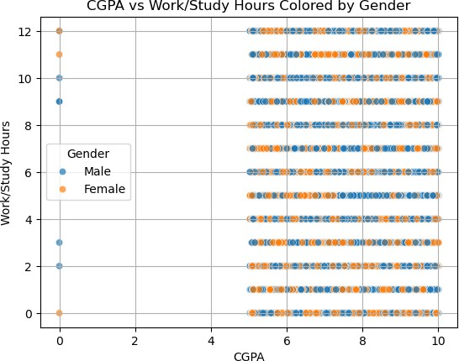

In [89]:

*#Work/Study Hours vs Age scatter plot*

plt**.**figure(figsize**=**(8, 6))

plt**.**scatter(shivam['Work/Study Hours'], shivam['Age'], color**=**'teal', alpha**=**0.5) plt**.**title('Work/Study Hours vs Age')

plt**.**xlabel('Work/Study Hours') plt**.**ylabel('Age') plt**.**grid(**True**)

plt**.**show()

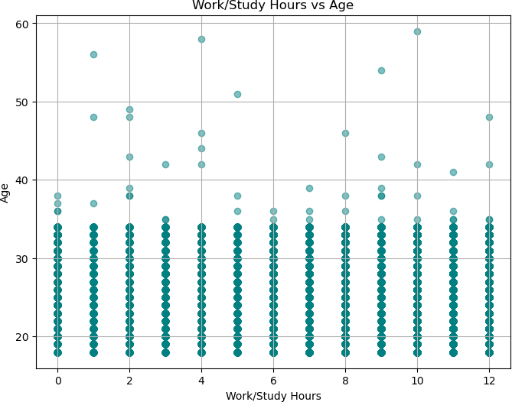

In [87]:

*# Scatter plot with hue based on Depression*

sns**.**scatterplot(x**=**'CGPA', y**=**'Academic Pressure', hue**=**'Depression', data**=**shivam) plt**.**title('CGPA vs Academic Pressure by Depression')

plt**.**xlabel('CGPA') plt**.**ylabel('Academic Pressure') plt**.**show()

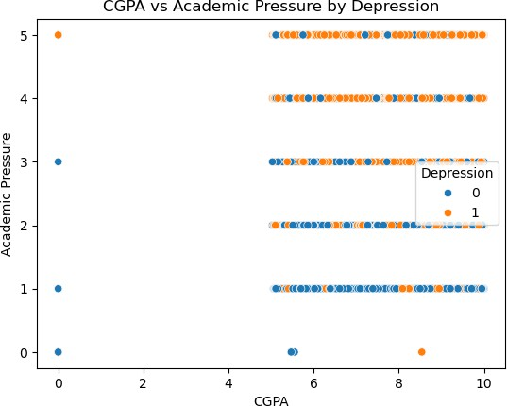

In [85]:

*# Scatter plot(CGPA vs Academic Pressure)*

plt**.**figure(figsize**=**(8, 6))

plt**.**scatter(shivam['CGPA'], shivam['Academic Pressure'], alpha**=**0.6, c**=**'purple') plt**.**title('CGPA vs Academic Pressure')

plt**.**xlabel('CGPA') plt**.**ylabel('Academic Pressure') plt**.**grid(**True**)

plt**.**show()

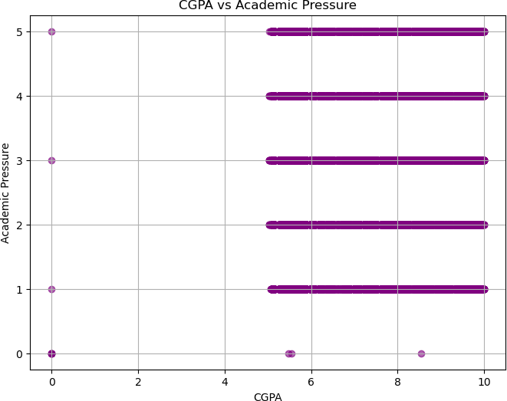

In [38]:

*# Bivariate Analysis Depression vs Gender* sns**.**countplot(x**=**'Gender', hue**=**'Depression', data**=**shivam) plt**.**title('Depression by Gender')

plt**.**show()

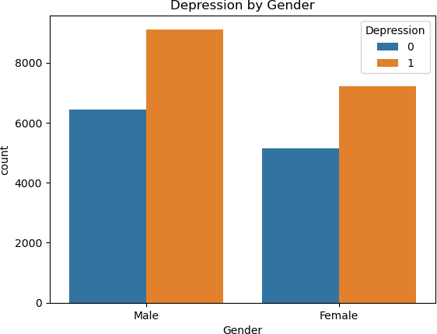

In [ ]:

In [40]:

*# Bivariate Analysis Depression vs CGPA* sns**.**boxplot(x**=**'Depression', y**=**'CGPA',hue**=**'Depression', data**=**shivam) plt**.**title('CGPA by Depression')

plt**.**show()

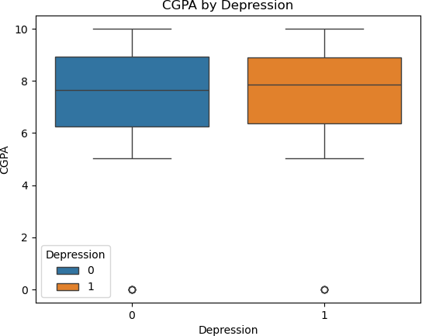

In [42]:

*# Bivariate Analysis Depression vs Academic Pressure*

sns**.**boxplot(x**=**'Depression', y**=**'Academic Pressure',hue**=**'Depression', data**=**shivam) plt**.**title('Academic Pressure by Depression')

plt**.**show()

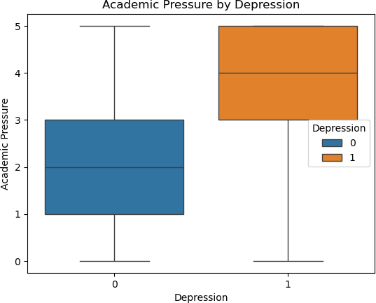

In [111…

*# Scatter Plot (Bivariate): CGPA vs Academic Pressure, colored by Depression* sns**.**scatterplot(x**=**'CGPA', y**=**'Academic Pressure', hue**=**'Depression', data**=**shivam, plt**.**title('CGPA vs Academic Pressure (Colored by Depression)') plt**.**xlabel('CGPA')

plt**.**ylabel('Academic Pressure') plt**.**grid(**True**)

plt**.**show()

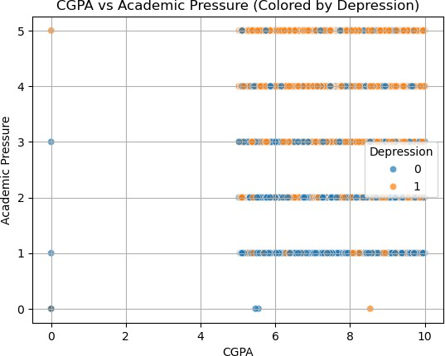

In [119…

*# Filter for Male& female students*

male_df **=** shivam[shivam['Gender'] **==** 'Male'] female_df **=** shivam[shivam['Gender'] **==** 'Female']

*# Get Depression value counts*

male_dep_counts **=** male_df['Depression']**.**value_counts() female_dep_counts **=** female_df['Depression']**.**value_counts()

*# Plot Mlae pie chart*

plt**.**figure(figsize**=**(6, 6))

plt**.**pie(male_dep_counts, labels**=**['Not Depressed', 'Depressed'], autopct**=**'%1.1f%% plt**.**title('Depression Distribution in Male Students')

plt**.**show()

*# Plot Female Pie Chart*

plt**.**figure(figsize**=**(6, 6))

plt**.**pie(female_dep_counts, labels**=**['Not Depressed', 'Depressed'], autopct**=**'%1.1f plt**.**title('Depression Distribution in Female Students')

plt**.**show()

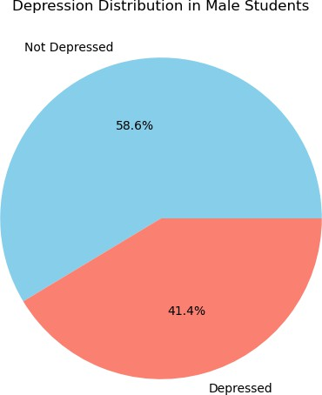

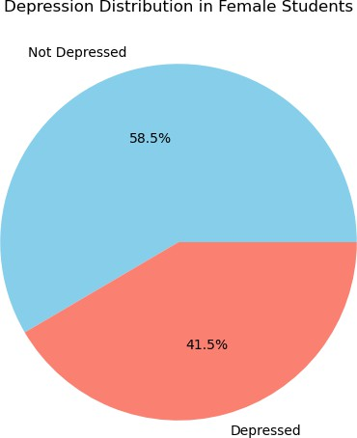

In [121…

*# Pairplot with Depression hue Multivariate Analysis*

selected_columns **=** ['Age', 'CGPA', 'Work/Study Hours', 'Academic Pressure', 'Dep sns**.**pairplot(shivam[selected_columns], hue**=**'Depression')

plt**.**suptitle("Pairplot of Selected Features", y**=**1.02) plt**.**show()

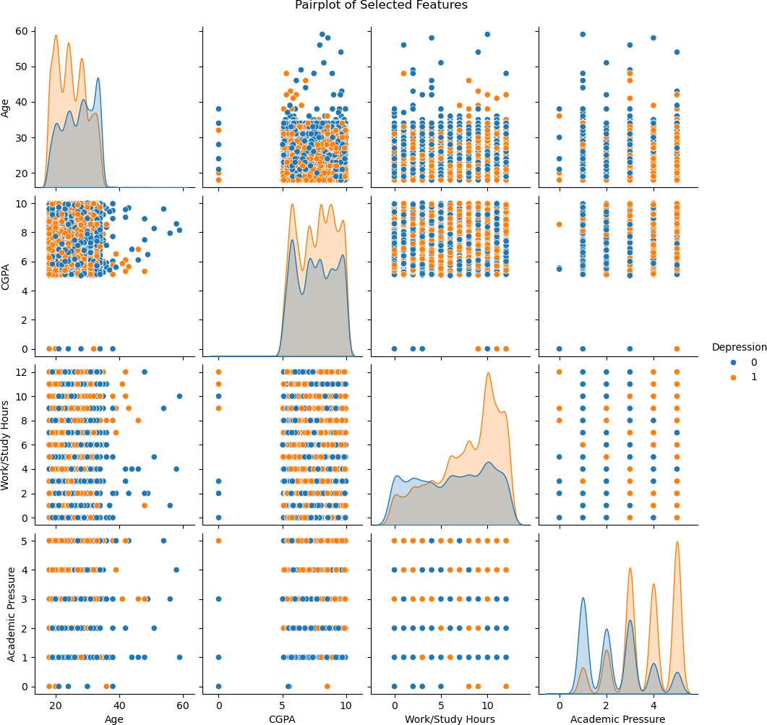

In [135…

*# Multivariate Scatter Plot* plt**.**figure(figsize**=**(10, 6)) sns**.**scatterplot(

x**=**'CGPA',

y**=**'Academic Pressure', hue**=**'Depression', size**=**'Work/Study Hours', style**=**'Gender', data**=**shivam, palette**=**'Set1',

sizes**=**(50, 250), *# size range for points*

alpha**=**0.7

)

plt**.**title('Multivariate Scatter Plot: CGPA vs Academic Pressure') plt**.**xlabel('CGPA')

plt**.**ylabel('Academic Pressure') plt**.**legend(bbox_to_anchor**=**(1.05, 1), loc**=**'upper left') plt**.**grid(**True**)

plt**.**tight_layout() plt**.**show()

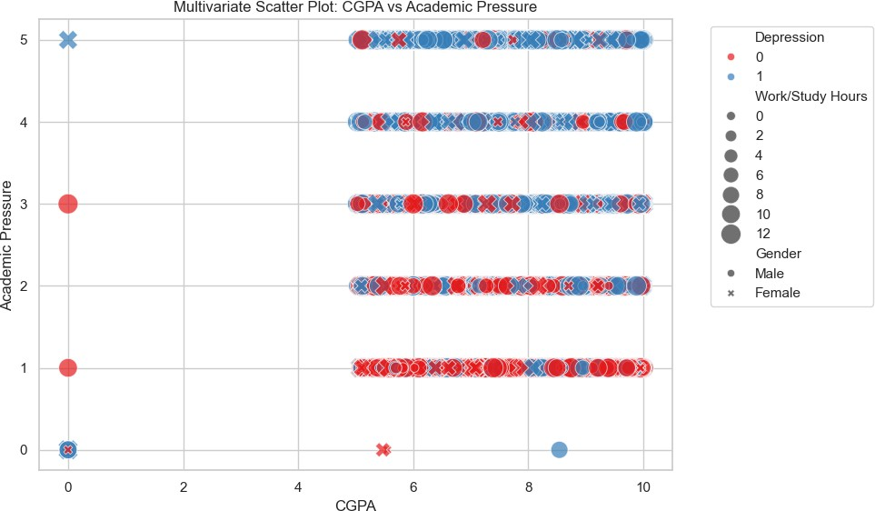

In [49]:

*# Correlation Heatmap*

corr_matrix **=** shivam**.**corr(numeric_only**=True**) sns**.**heatmap(corr_matrix, annot**=True**, cmap**=**'coolwarm') plt**.**title('Correlation Heatmap')

plt**.**show()

